**Suggested Reading:** *Modern Quantum Mechanics* [1], reference [2]

**Vocabulary Words:**

**Spherical Harmonics:** A complete set of orthogonal functions with many important theoretical and particle applications. In particular, a specific subset of spherical harmonics are known for being the angular component of the energy eigenfunctions for a single electron in an atom.

**Selection Rules:** The rules which dominate which energy eigenstates can be transitioned between for a given operator. The rules are usually defined in terms of allowed jumps between quantum numbers, and change depending on the perturbation causing the transition.

**Exercise:**  There are roughly 60 X-ray and vacuum ultraviolet (VUV) light sources all over the world. Below is a diagram for the ones contained in the America’s. Fill the bubbles with the numbers that correspond to the light source located in each area.



1. Aichi Synchrotron Radiation Center
2. Australian Synchrotron
3. Beijing Synchrotron Radiation Facility  
   (BSRF)
4. Hiroshima Synchrotron Radiation Center
5. National Synchrotron Radiation   
   Laboratory (NSRL)
6. National Synchrotron Radiation   
   Research Center (NSRRC)
7. Photon Factory
8. Pohang Light Source-II
9. Pohang Accelerator Laboratory (PAL) X-ray Free Electron Laser
10. Soft X-Ray Free Electron Laser (SXFEL)
11. Ritsumeikan University SR Center (RitsSR)
12. Indus-1
13. Indus-2
14. SAGA-LS
15. Synchrotron Light Research Institute (SLRI)
16. SPring-8
17. Singapore Synchrotron Light Source (SSLS)
18. Shanghai Synchrotron Radiation Facility (SSRF)
19. High Energy Photon Source (HEPS)
20. Introduction:
21. From time dependent perturbation theory, the probability (per unit time) of an electron transitioning from an initial to a final state is given by the equation below.

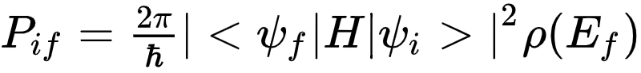

What is the physical significance of ? What is this equation famously known as?

The transition amplitude squared term is the overlap integral between the initial and final state under the influence of the perturbing Hamiltonian, the electromagnetic field of the photon. This equation is known as Fermi’s Golden rule and it takes this form under the assumption that the time it takes for the measurement to occur is much larger than the time it takes for the transition from initial to final state to occur.

1. To first order the relevant Hamiltonian for a classical radiation field is where is the vector potential of the wave and is the momentum operator of the electron. The vector potential can be written as

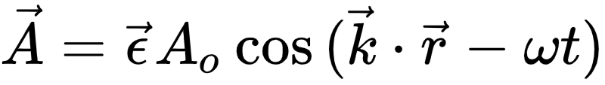

where is the polarization of the photon. Use the Hamiltonian and the exponential form of the vector potential to rewrite fermi’s golden rule for the transition probability of x-ray absorption. (Hint: Note that only the term corresponds to absorption, while the term corresponds to stimulated emission. For more information see Sakurai pg. 365 [1])

Solution:

P_{if} = \frac{2\pi}{\hbar} |<\psi_f|H|\psi_i>|^2 \rho(E_f) \\
= \frac{2\pi}{\hbar} |<\psi_f| \frac{e}{m_e c}\vec{A} \cdot \vec{p}|\psi_i>|^2 \rho(E_f) \\
= \frac{2\pi e}{m_e \hbar c} |<\psi_f| \vec{\epsilon} \cdot \vec{p} A_o (e^{i\vec{k} \cdot \vec{r} - i \omega t} + e^{- i\vec{k} \cdot \vec{r} + i \omega t})|\psi_i>|^2 \rho(E_f) \\


Keeping only the absorption term

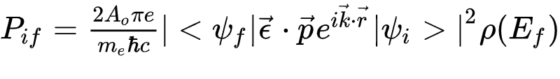

1. The expression you derived in the previous problem can be simplified via the dipole approximation, which makes the assumption

\vec{k} \cdot \vec{r} \ll 1


Use the dipole approximation to find this simplified form. Is this approximation valid for the typical x-ray absorption experiment? Consider Cu. Use the wavelength of a photon with sufficient energy to excite the K-edge, and compare that to the K-shell diameter.

Solution:

P_{if} = \frac{2 A_o \pi e}{m_e \hbar c} |<\psi_f| \vec{\epsilon} \cdot \vec{p} e^{i\vec{k} \cdot \vec{r} }|\psi_i>|^2 \rho(E_f) \; \textrm{for} \; \vec{k} \cdot 
\vec{r} \ll 1 \\
P_{if} \approx \frac{2 A_o \pi e}{m_e \hbar c} |<\psi_f| \vec{\epsilon} \cdot \vec{p} (1+i(\vec{k} \cdot \vec{r}) - \frac{1}{2}(\vec{k} \cdot \vec{r})(\vec{k} \cdot \vec{r}) + \; ...)|\psi_i >|^2 \rho(E_f) \\
\quad \quad \; \; \;   \frac{2 A_o \pi e}{m_e \hbar c} |<\psi_f| \vec{\epsilon} \cdot \vec{p}|\psi>|^2 \rho(E_f)



Cu K edge is at 8.9 KeV. A photon with that energy has a wavelength of 1.3 Angstroms which corresponds to a wavenumber of . The 1s shell of Cu has a radius of about 0.02 Angstroms, so .

1. In the previous problem you used the dipole approximation to Taylor expand the exponential, keeping only the first term in the expansion. The next term in the expansion is known as the quadrupole term.

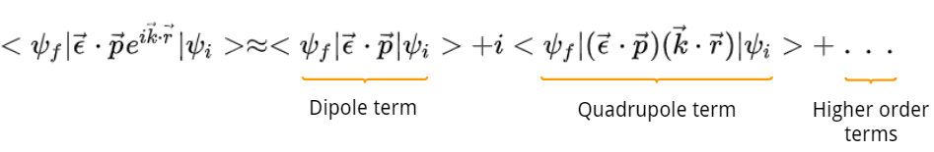

The ratio of the quadrupole and dipole contributions is roughly <kr>. We can approximate r as the radius of the 1s electron in a hydrogenic model, and we can approximate k, the wavevector of the photon, by using the binding energy of the 1s electron. If you are unsure of how to do this, note that we can use

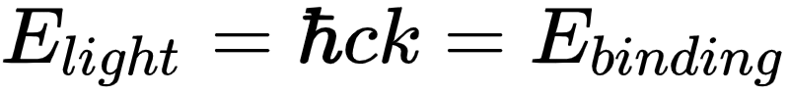

to determine the wavevector of the photon that is needed to excite the 1s electron out of the atom. In the table below, estimate the ratio of the quadrupole and dipole contributions using the product of k and r. Based on this, comment on the validity of the dipole approximation as a it relates to the atomic number of the element being studied.

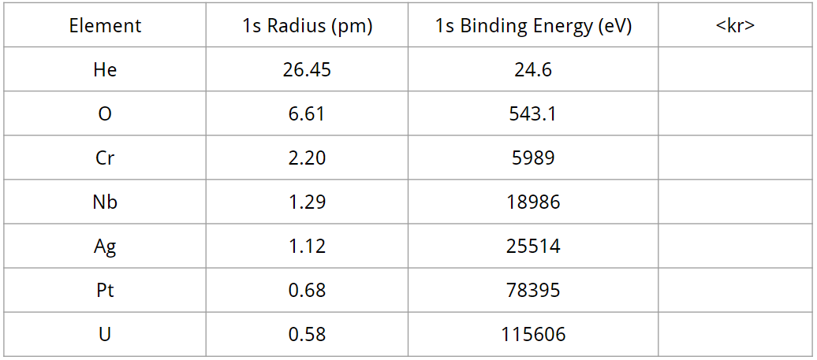

<kr> values: 0.3%, 1.8%, 6.7%, 12%, 14%, 27%, 33%

1. Selection Rules
2. The main takeaway from the form of the transition amplitude that you derived using the dipole approximation is that it is dominated by the overlap integral:

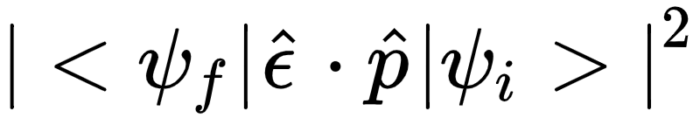

The general form of the dot product between the photon polarization and the electron momentum is given below. Note that it can also be written in terms of spherical harmonics.

\vec{\epsilon} \cdot \vec{p} = \epsilon_x sin(\theta)cos(\phi) + \epsilon_y sin(\theta)sin(\phi) + \epsilon_z cos(\theta) \\
\quad \; \; \; = \sqrt{\frac{4}{3}} \left( \epsilon_z Y_{1,0} + \frac{-\epsilon_x + i \epsilon_y}{\sqrt{2}}Y_{1,1} + \frac{\epsilon_x - i \epsilon_y}{\sqrt{2}}Y_{1,-1}  \right)

Now consider the overlap integral in terms of the angular components of the wave function. For the following initial and final states (in terms of spherical harmonics), determine whether the overlap integral will be zero or non-zero.

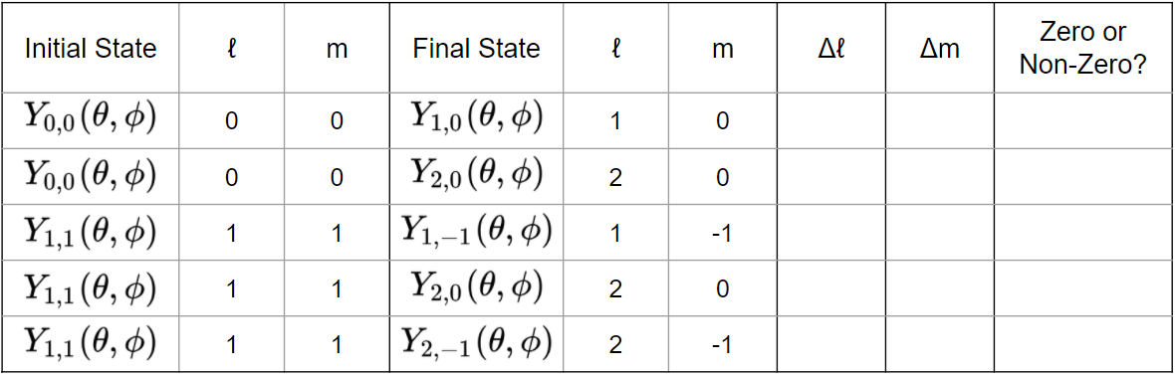

The expressions for the relevant spherical harmonics are: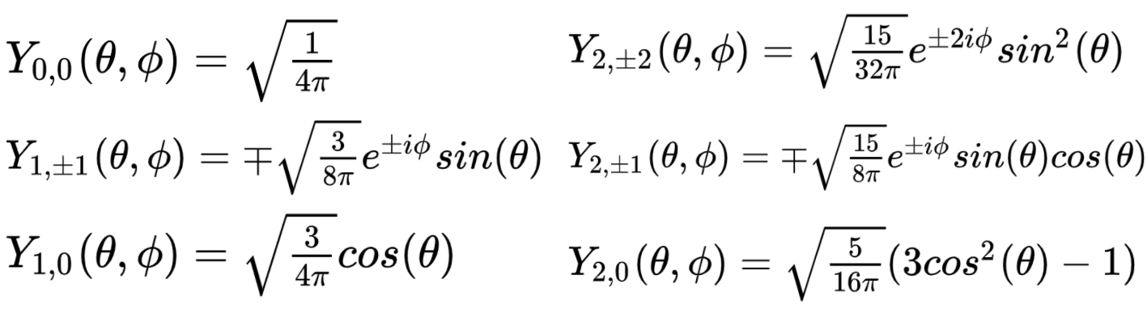

However, be aware that you do not necessarily need to compute the overlap integrals to be able to tell if they are zero or non-zero. (Hint: Pay attention to the symmetry or asymmetry of the functions. Recall that theta is being integrated from 0 to 𝜋. Finally, do not forget that the final state must be complex conjugated.) What famous rule does this problem demonstrate?

Non-zero, Zero, Zero, Non-zero, Zero

Dipole selection rule:

1. When a photon having energy far above is binding energy is absorbed in a crystalline solid, the resulting photoelectron is said to go into ‘the continuum’, meaning the continuum of states that exist from high-energy bands. We of course know that electrons in band theory are described by Bloch waves, i.e., plane waves with crystal momentum k. This plane wave can be expanded in terms of spherical harmonics (see ref [2])



Consider the following transitions to the continuum. For each, write if it is allowed (non-zero overlap integral) and if so, which spherical harmonic terms from the Bloch wave expansion actually contribute.

1. Transition from the 1s initial state to the continuum:

A 1s initial state has . Therefore, according to the dipole selection rules that we derived earlier, the overlap integrals involving the spherical harmonics with from the Bloch wave expansion will be non zero and contributing.

1. Transition from 2px initial state to the continuum:

The 2px usually follows the convention of corresponding to quantum numbers Thus, the contributing spherical harmonics will have as well as .

1. Transition from 3dz^2 initial state to the continuum:

The 3dz^2 corresponding to quantum numbers Thus, the contributing spherical harmonics will have and well as .

1. In an earlier section we concluded the pre-edge peak in the XAFS was connected to the coordination geometry of the system being studied. The pre-edge peaks of Cr(VI) (from sodium chromate NaCrO4) and Cr(III) (from Chromite Cr3O4) are shown in the figure below [4], with the Cr(VI) having tetragonal symmetry and the Cr(III) having octahedral symmetry. 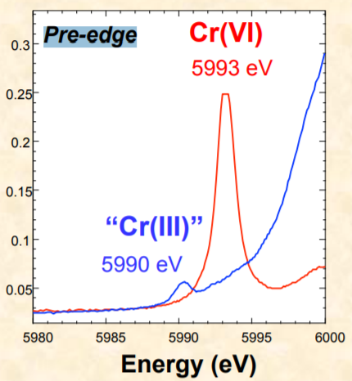

Keep in mind that the figure shows the Cr K-edge, meaning an electron is excited out of the 1s shell, and the lowest unoccupied states in Cr are d states. Given what we have discussed so far about the dipole selection rule, what does the difference in the pre-edge heights of Cr(III) and Cr(VI) imply?

The p and the d orbitals mix more in the Cr(VI) complex than in the Cr(III) system. We know this because the dipole selection rule restricts absorption events to transitions occurring between the s and p orbitals. However, the mixing of the p and d orbitals gives the K-edge photoelectron access to the unoccupied states within the 3d orbital. The Cr(VI) complex has the larger pre-edge height, which allows us to conclude that it has more p and d orbital mixing than Cr(III).

1. Recall that in an earlier section we studied the pre-edge peaks in the XANES region of a few Vanadium oxides. V2O3 has a formal oxidation number of -3, and a weak pre-edge peak. V2O5 has a formal oxidation number of -5, and a strong pre-edge peak as shown in the plot below.

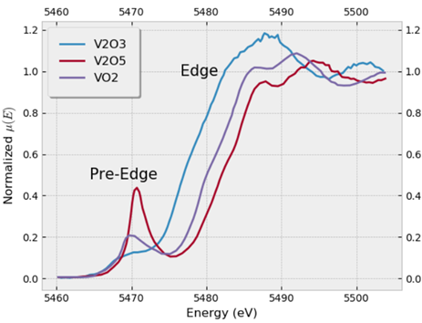

The next two plots show the angular momentum-projected local final density of states for V2O3 and V2O5 as calculated by real-space green’s function code FEFF [3]. Note that while these do not agree exactly with experiment, they are accurate enough to demonstrate the physics relevant to this question. Consider the unoccupied density of states (the portion above the fermi level). What is it about the overlap of the p-DOS and d-DOS for the two systems which would explain the pre-edge behavior in their respective K-edge XAFS spectrums? Frame your explanation in the context of what we have covered so far in this section.

**V2O3 V2O5**

**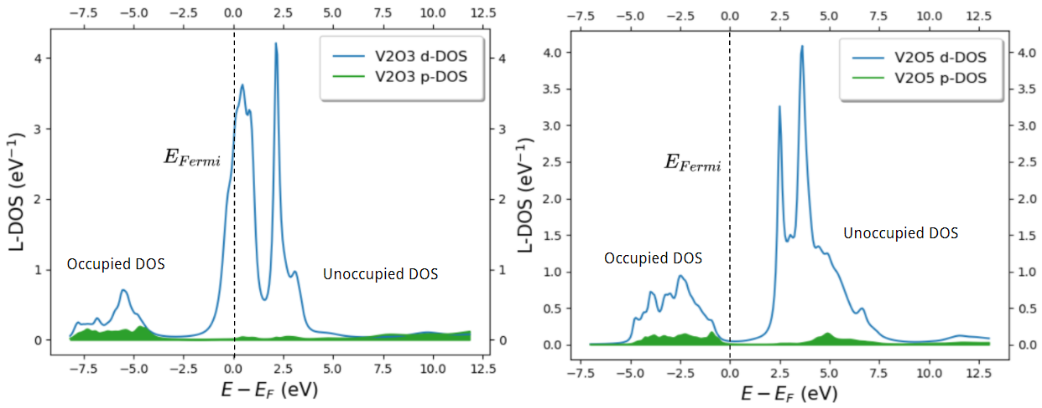**

There is more overlap between the p and d density of states for V2O5 than there is for V2O3. This allows us to conclude that the unoccupied V2O5 3d states have more p character than the same states in V2O3, meaning that even though the dipole selection rule forbids transitions between the s and d shells, the mixing of the p and d orbitals allows for a distinct pre-edge peak that we observe for V2O5 in the earlier figure.

Citations:

[1] Sakurai, J. J., and Jim Napolitano. *Modern Quantum Mechanics*. Addison-Wesley, 2011.

[2] “Plane Wave Expansion.” *Wikipedia*, Wikimedia Foundation, 10 June 2020, en.wikipedia.org/wiki/Plane\_wave\_expansion.

[3] Rehr, John J., et al. “Parameter-Free Calculations of X-Ray Spectra with FEFF9.” *Physical Chemistry Chemical Physics*, vol. 12, no. 21, 2010, p. 5503., doi:10.1039/b926434e.

[4] Foster, Andrea L. *Improvement of a Cr(VI) Extraction Method for Chromite Ore Processing Residue (COPR)-Contaminated Materials*. July 2015, nemc.us/docs/2015/presentations/Thu-Contaminated Sediments-10.2-Wolf.pdf